1
Before
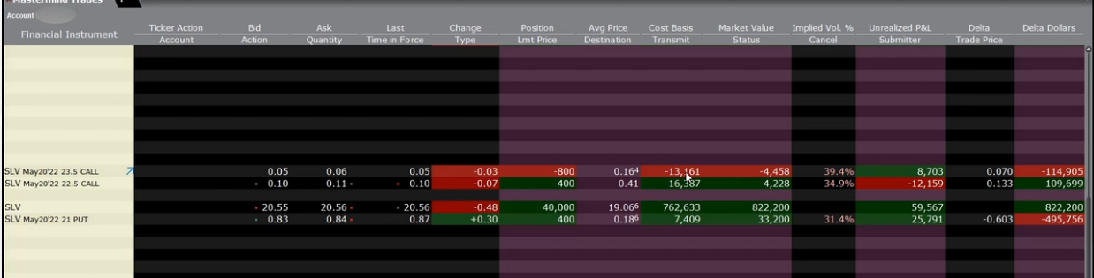
After
2
Before
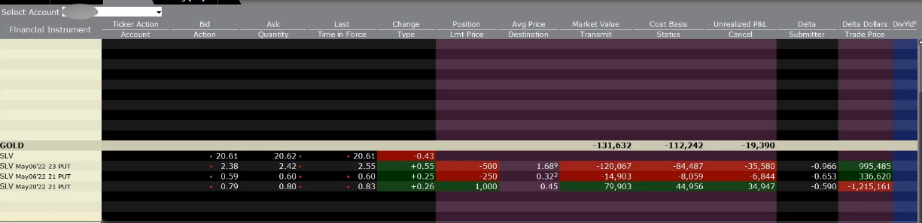
After
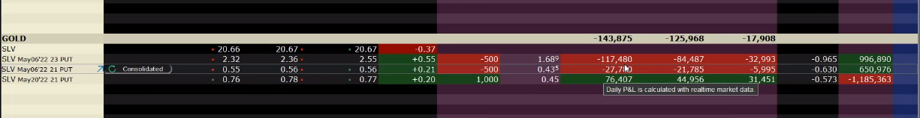
And then
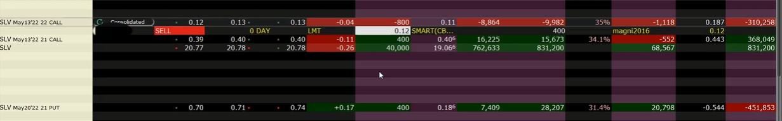
Try to anticipate rebound, paid by covered calls


